Reducing Customer Churn at ACME with Time-Travel-Enabled Insight
October 14, 2022
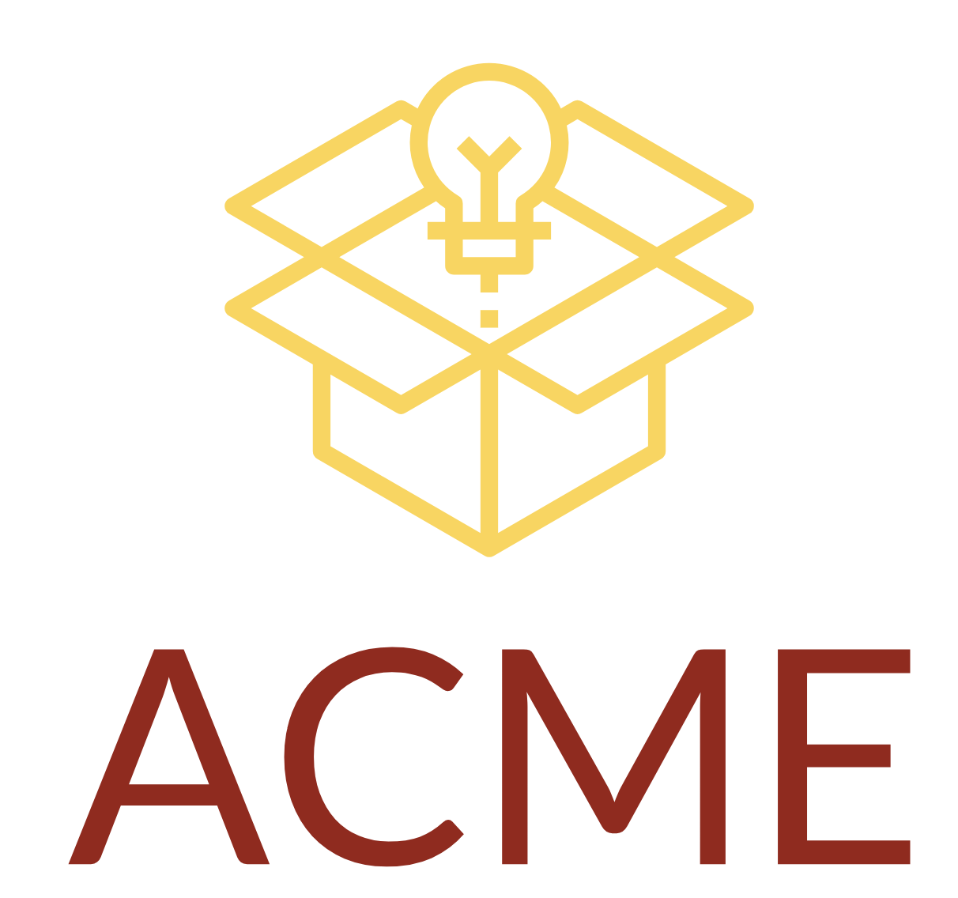

Introduction
Thank you for the opportunity to help ACME reduce customer churn and increase subscription renewal rates. Our team at Paradocx is excited to introduce your organization to the business benefits of time travel. We appreciate Ernie Roadrunner explaining your challenges with delivery to remote locations, coyote-proofing explosive and Rube Goldberg inventory, and the competitive pursuit being given by upstart Zambezi. This proposal will illustrate how our Time Travel SaaS Platform can help with those challenges and more.

Expected Results
Based on ACME’s goal to have a solution up and running within 90 days, we expect the following results:
- Eliminate regret and fear of making wrong decisions by 100%, accelerating response time by 3x.
- Achieve 150% ROI (subscription-level agnostic) and finalize up to 10 customer retention packages based on Time Travel machine learning analysis within 90 days.
- Establish a redundancy plan to guarantee all future delivery locations based on Time Travel insight into future customer requests.
- Initiate rewards program promotions to customer profiles most likely to be targeted by Zambezi and other competitors.
- Identify coyote influencer to lead explosives safety education and training programs.

Pricing Options
We designed three pricing subscriptions, all of which will help ACME reduce customer churn to varying degrees.
- Single user: 10 Bitcoin (annual). Enable coyote account manager to Time Travel for unlimited accounts with unlimited collaborators within designated projects (best for targeted accounts).
- >25 users: 100 Bitcoin (annual). Deploy Time Travel for ACME shipping & packaging department, again for unlimited accounts with unlimited collaborators (best for scalability and future planning).
- Unlimited users: $1T coin (one-time fee). Deploy Time Travel company-wide at ACME with zero platform restrictions and VIP services for Future Projection Beyond Tomorrow (best for white glove coyote service and world domination).

Scope of Work
Go-live set for 90 days after purchase date. Our technicians will be operating virtually beyond the astral plane and will require full access to all ACME data assets. Security is guaranteed because the World Time Congress has granted an exemption for our team to use Time Travel to build non-chaotic Einstein Rosen bridges across all incursion attempts. End-user training begins one week prior to go-live. First look into the past occurs day one. First look into the future occurs day 180.
More information on terms, conditions, and implementation:
- ACME Onboarding Map
- ACME Security Requirements
- ACME Warranty: “How Do I Change It Back?”

Next Steps
Thank you again for allowing Paradocx to propose a solution to make ACME the world’s safest, fastest package and delivery company, even for coyotes. We look forward to answering any questions during our proposal follow-up call on Wednesday, October 9, at 10A PST.
I, the undersigned, accept this proposal and request that Paradocx create a formal contract for the pricing option selected above.

Approved: __________________________________________________
Bugs Bunny
President/CEO, ACME Inc.
Date: _________________________________________________

